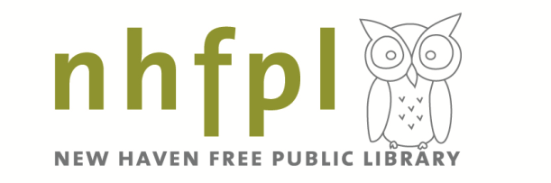
Ives Gallery
2020 Proposal

Please read the Ives Gallery 2020 Guidelines before completing the proposal.

- Contact Information
Name:
Address:
Phone:
Email:
Website:

- Artists Bio & Statement, Organizational Mission Statement or Statement of Purpose
Please provide an Artists Bio & Statement, Organizational Mission Statement or Statement of Purpose as appropriate to your proposal. (I.e. artists should complete an artist bio and statement, nonprofits and schools should provide a mission statement and curators should provide a statement of purpose.)

- Proposed Exhibition Title

- Proposed Exhibition
Please provide a brief description and scope of the proposed exhibition.

- Artwork and Documentation
To be eligible, you must have at least 20 artworks ready to exhibit. Do you have at least 20 artworks?
Yes No

Please provide the following information for the 3-5 images you are including with your proposal.

  - Artist:
Title:
Dimensions:
Medium:
Date (YYYY):

  - Artist:
Title:
Dimensions:
Medium:
Date (YYYY):

  - Artist:
Title:
Dimensions:
Medium:
Date (YYYY):

  - Artist:
Title:
Dimensions:
Medium:
Date (YYYY):

  - Artist:
Title:
Dimensions:
Medium:
Date (YYYY):

- Exhibition Dates
Please rank your preference of the following exhibition dates from numbers #1 to #6, #1 being your first choice and #6 being your last choice. If you do not have a preference, please feel free to leave these blank.

Exhibition 1
January 25 – March 20, 2020

Exhibition 2
March 28 – May 15, 2020

Exhibition 3
May 22 – July 17, 2020
Exhibition 4
July 25 – September 18, 2020

Exhibition 5
September 26 – November 13, 2020

Exhibition 6
November 21, 2020 – January 15, 2021
- How did you hear about the Ives Gallery open call?

NHFPL website
NHFPL Happenings Newsletter Email
NHFPL social media
The Arts Paper/ Arts Council of Greater New Haven
Open Call Postcard
Other. Please share!

- Attachments
- Resume or CV
- If applying with more than one organizer (i.e. a group of artists, two teachers or two curators), please include a resume for each person.
- 3-5 images of recent work, current work or the work specifically intended for the proposed exhibition. These can be uploaded as separate files.

Please feel free to use an electronic signature by typing your name and the date.

Signature

Date

